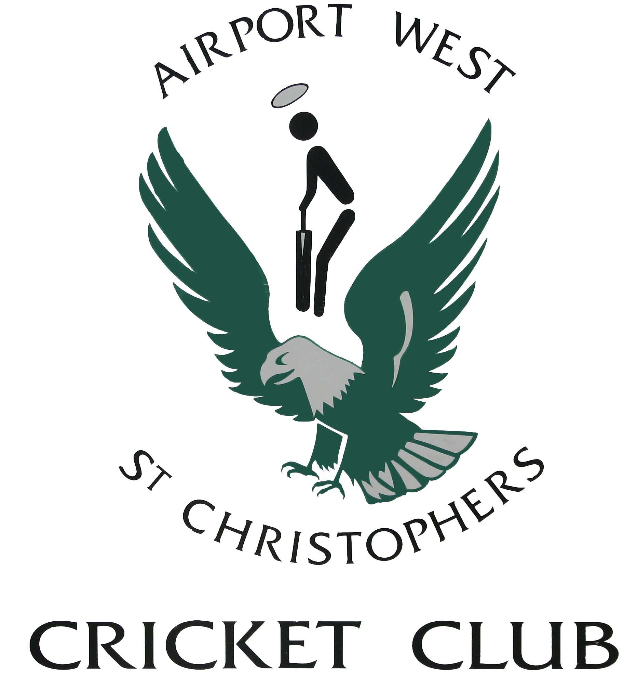
AIRPORT WEST ST. CHRISTOPHERS CRICKET CLUB INC.

Affiliated with V.T.C.A & N.W.M.C.A

ABN: 80 905 721 530

Clubrooms: Hansen Reserve, Etzel Street, Airport West. Phone # 9335 4539

Correspondence: P.O. Box 414, Niddrie 3042
Website: www.apwstc.vic.cricket.com.au

15 July 2024

Hello all,

Well what a season it was.
We are now a Senior Division club after both the 1st and 2nd XI winning their grand finals. A long time between drinks for the 1st XI to capture that flag.

To say it was an easy season is far from the truth. It was a testing, interesting one, that the committee and supporting staff assisted in pulling AWSCCC through.
VTCA competition was a mix of predominantly 2 day matches with a few one day game scattered throughout for the Saturday competition, and we trialed a Sunday Turf competition with some succuss.
A thankyou and congratulations to:
Club Coach – Alan Torrance
1st X1 Captain – Daniel Salpietro
2nd X1 Captain – Scott Woolcock
A massive thank you to all leaders, players and supporters. 30 years since we won both the 1st and 2nd X1 flags
With winning the flag and the team effort across the season, there are always hard calls to make when it comes to selection at finals time – thank you to the “selection panel” for working through the issues.
Unfortunately we were not able to get a Saturday synthetic competition up to compete in the NWMCA (this was not without trying)

On a positive note for the club, we have a burgeoning junior competition. Feilding, 2 Saturday under 14’s, Friday night under 16’s, 2 Under 12’s along with an under 10’s plus our Thursday night under 12’s is a glowing reflection to all involved that the club is in a good position. Winning finals isn’t everything as but we can hold ourselves high that we are a club that provides opportunity for community cricket to be played.
We can’t forget our blasters program operated on a Friday night with Steve Carroll stepping up to run. Numbers were fluid across the season but we have already help preliminary meeting with Cricket Victoria for the future on how we can successfully tap in to co-tenant club AWFC and their huge Auskick program they have to increase our numbers.
A very big thank you to the coaches in Steve Carrol, Phil Peel, Ben Ditfort, Ben Frendo and Greg Jones across the juniors for getting the teams up and matches occurring (and to all the support network behind those coaches making the matches happen).

It is something I repat every season in the report but it sometimes is a thankless task sorting out the speed bumps each season, and putting the various headbutts that occur, parents opinions aside, seeing the the club wining in the seniors and the juniors come off the field after each match smiling even if they have lost, is a testament to the volunteers, that each match we are doing something correctly.

Off field club wise we had functions occur with our Past Players Day, Christmas Raffle and Ladies day being a success.
Off-field the season also got a boost thanks to the, usual suspects of the Airport West Tennis Club, Northern Suburbs Golf Club, TWU, Bambino Child care and other private functions across the season.

CC Exec were required to work with senior leaders at Moonee Valley City Council, Sports and Recreation and Parks and Gardens in relation to the curator we had engaged to prepare our wicket, Ultimately we had to terminate our arrangement with our curator half way through the season, and then find a new curator – which we did with the assistance of Council. Thank you to our club Executive members who assisted in somewhat difficult negotiations with Council, We managed to navigate our way through the issues, and have a pitch prepared each week, including finals. Unfortunately it looks like we will need to find a new curator for the coming season, again!!

Committee has worked closely with Council and Airport West Football Club on the following:
Replacement of the fence around Etzel Street Reserve, without interruption to fixtured home matches – was a close call the first week – delays caused by Council needing to engage Downer industries due to gas pipeline in close proximity to the fence.
Renovation of the cricket training nets – design work to replace netting in all nets, install padding around nets at batting end, extend run ups, and install power bollard (allows bowling machine to by plugged in instead of using a generator). The nets renovation is funded by council, and is in the 24-25 Council budget. We expect works to be undertaken at the end of the 24-25 cricket season.
Remedial ground work to remove the “hump” just off the turf wicket square at the clubroom ends of Etzel Street. Council have reviewed and advise that the ground around the wicket square has “sunk”. Quote/s have been obtained and referred to Council for work to be undertaken. We understand that this work will commence along with the square preparation in August, in time for an on time start in October.

Ray Kinzel Estate.
Significant time has been spent behind the scenes, working with Ray’s solicitors, as executor of his will. We have finally been able to access some revenue via Ray’s estate, but this has involved a number of meetings with the Ray’s representatives for justification of the expenses. We are in the process of quoting for renovation of the unit to modernize for future use.

Looking forward to season 2024/2025, it will be a challenging task to continue our success. On preliminary indications, it appears our number across all formats look good allowing for the juniors to continue, and senior synthesis to return. Senior Turf will be a challenge with some unexpected changes with the VTCA competition occurring. We have voiced our concerns on these changes strongly and are awaiting a formal response. This is still a frustrating work in progress.

Also a thank you to our sponsors in NWI Group, MJS Construction Group, Watershed, Icon, Poolwerx, and QAElectrical for their support.

Lastly a big thank you to the fellow committee members in, Narelle Toz, Steve, Scott, John and Jon, along with Bill,
Thank you also to Tracey, Connor, Elizabeth, the Peel Family, Mick Frendo, Lisa, Olga, Shona and Rachel for your assistance and help this season along with many others.

Dale Mundy
President
Airport West St Christophers Cricket Club

